Program Benefits
- A Safe, Sober Environment
- Case Management Services
- Meals Served Monday – Friday
- Peer Supports
- Free Laundry Facilities
- Central Location
- Low Cost – 30% of Income

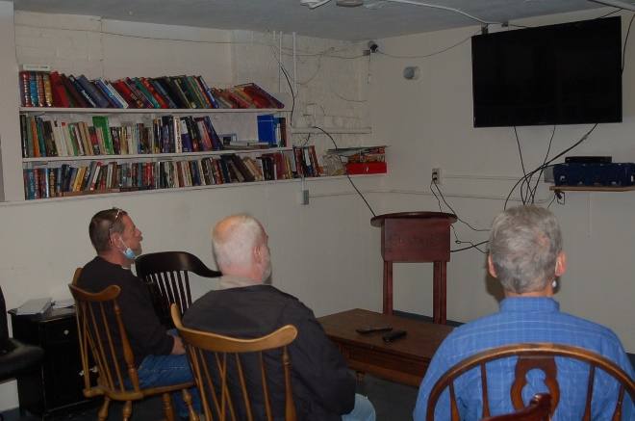
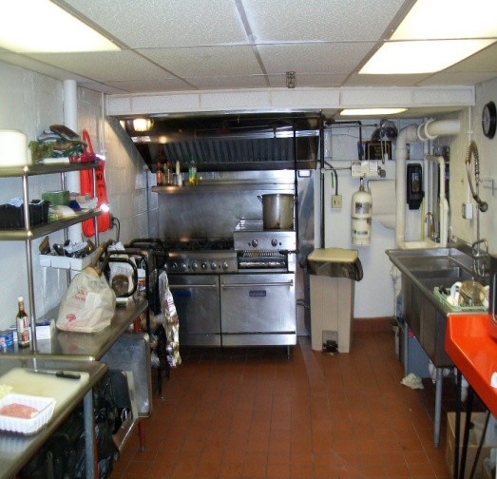
Helping Hands Outreach Center was established over 25 years ago by local Christians led to show God’s love in practical ways to help men recovering from substance use issues. We address the “Opioid Crisis” in South-Central N.H by providing low-cost, safe, sober housing at our facility on Lowell Street in Manchester. We assist men transitioning from treatment centers, prison, and homelessness so they can responsibly reintegrate into mainstream society. The men are provided a structured substance free place to call home. There is regular drug testing, employment counseling, referral to local services, and access to numerous support groups such as AA, NA, and Celebrate Recovery.
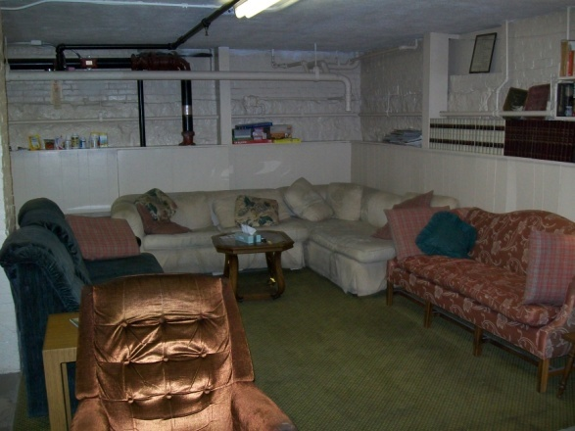
Executive Director Larry Nice has more than 25 years of experience helping men re-enter society. Our Chaplain Dr. Tim Lanigan is a Certified Life Coach. Case Manager, Fran Raudonis has over 40 years of experience helping men and women with their recovery.
Helping Hands offers recovering men the supports of housing, food, peer support, laundry facilities, and dinner, which is served Monday through Friday. There is a computer room for job searching and a common room with cable television.

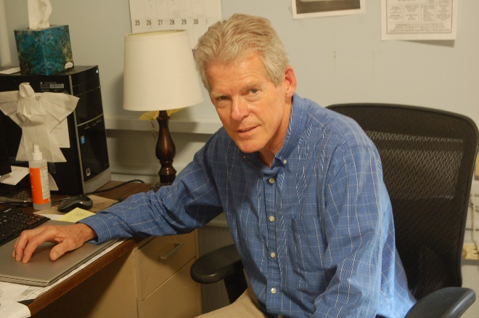
Director: Larry Nice
   
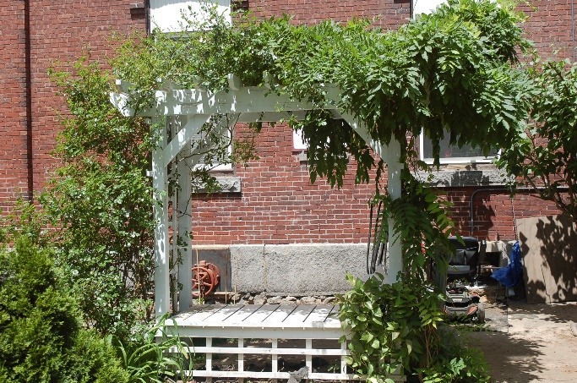

Located across from the Red Arrow Diner and one block away from Manchester’s Elm Street, this is a convenient site for men who are starting to live their lives again. Many meetings, churches, and services in the area are within walking distance.
http://helpinghandsmanchesternh.com

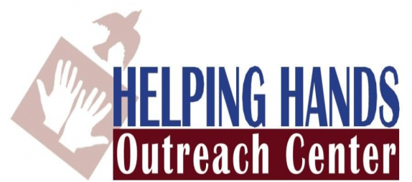
Helping homeless men, motivated to live sober, responsible lives. 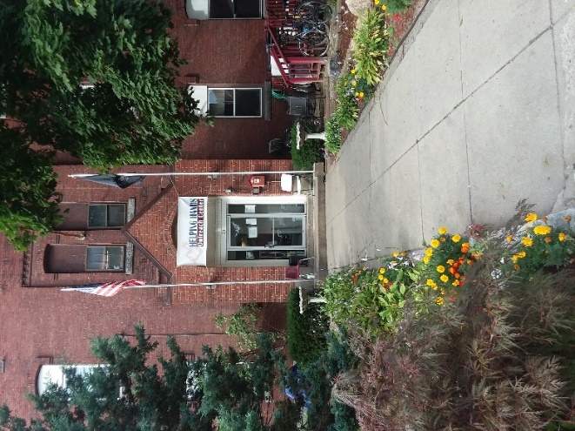
50 Lowell Street
Manchester, NH 03101
603-623-8778

